**EXPERIMENT 7**

**DQL COMMANDS (COLLEGE SCHEMA)**

**Aim:**

1)Display student id and marks from the student table.

2)Display faculty id and name from the faculty table.

3)Display who got grade A.

4)Display whose marks are less than 50.

5)Display the female students whose marks are between 50 to 60.

6)Delete the failed students.

7)Display activity id and name using object.

8)Display student id, faculty id using course name condition with object.

9)Select department name starting from ‘c’ and faculty name ending with ‘ ’.

10)Select activity having characters between ‘ck’.

11)Group by faculty id and display.

12)Display the students list whose grade is A using having.

13)Display the faculty list who are teaching PPS.

14)Apply aggregate functions in student marks - max, min, sum, count, avg.

**Code:**

1)select stud_no,marks from student;

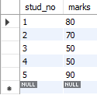

2)select fac_id,fac_name from faculty;

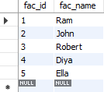

3)select * from student where grade='A';



4)select * from student where marks<50;



5)select stud_no, stud_name from student where marks> 50 and marks <60 and gender='F';



6)delete from student where marks<50;

select * from student;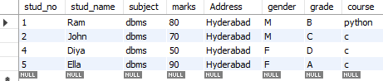

7)select a.act_id,a.act_name from activity a;

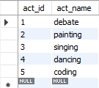

8)select s.stud_no,f.fac_id from student s,faculty f where s.course=f.course;

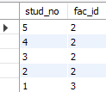

9)select dept_name,fac_name from department,faculty where dept_name like 'c%' and fac_name      like '%a';

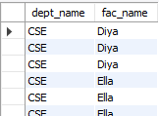

10)select * from activity where act_name like '%dm%';



11) select fac_id from faculty group by fac_id;

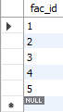

12) select stud_name from  student group by grade having grade='A';



13) select fac_name from faculty group by course having course='python';



14) select avg(marks), min(marks),max(marks),sum(marks),count(marks) from student;

